Exercise 1:

The expected result:

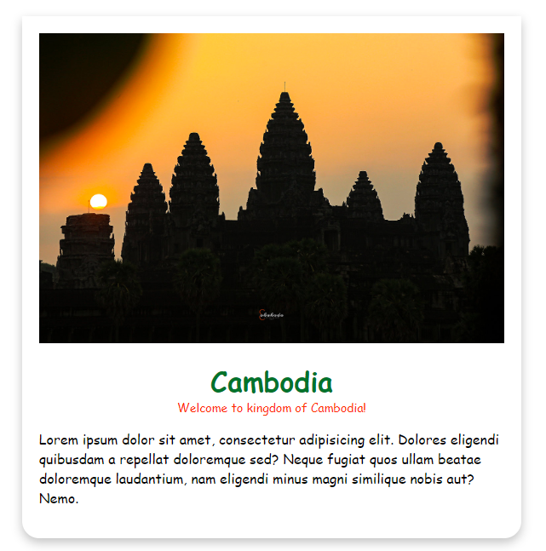

The existing code

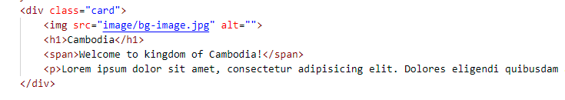

You need to code it following the code on html file.

Exercise 2:

This is the list websites that we stored it in the array of objects.

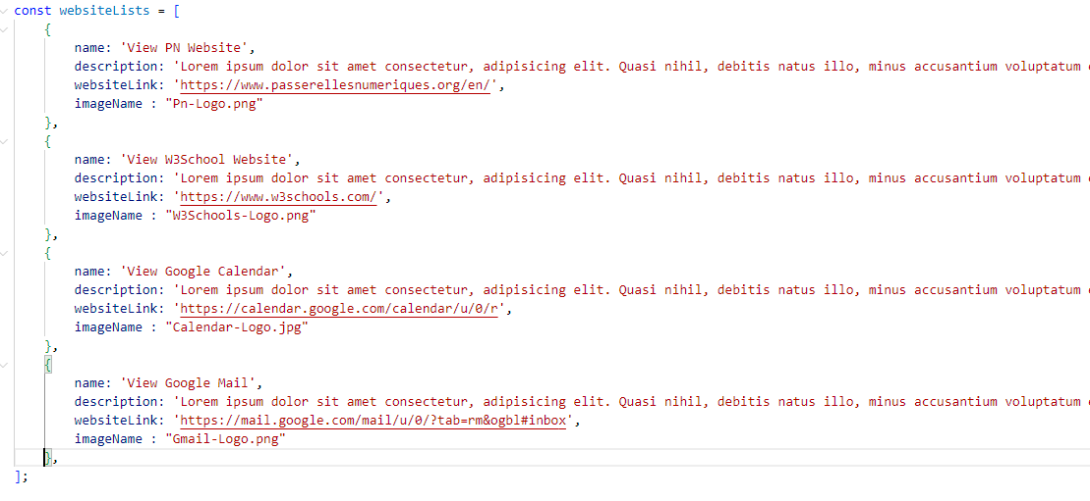

And we need to transform it into the template below following the HTML code structure.

The HTML code:

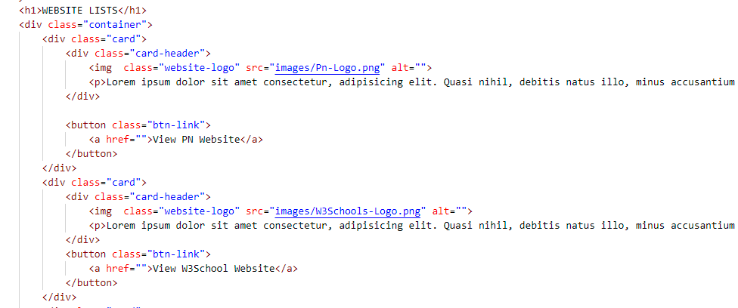

The template:

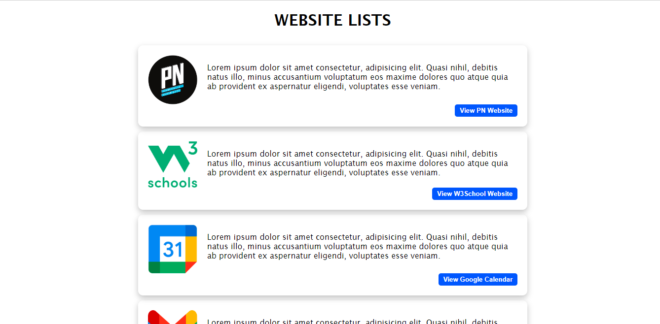

Exercise 3:

For this exercise is let you do on register form which you can register your own data such as:

* Your full name
* Your Gender
* Your batch
* Your skills
* And Your Bio

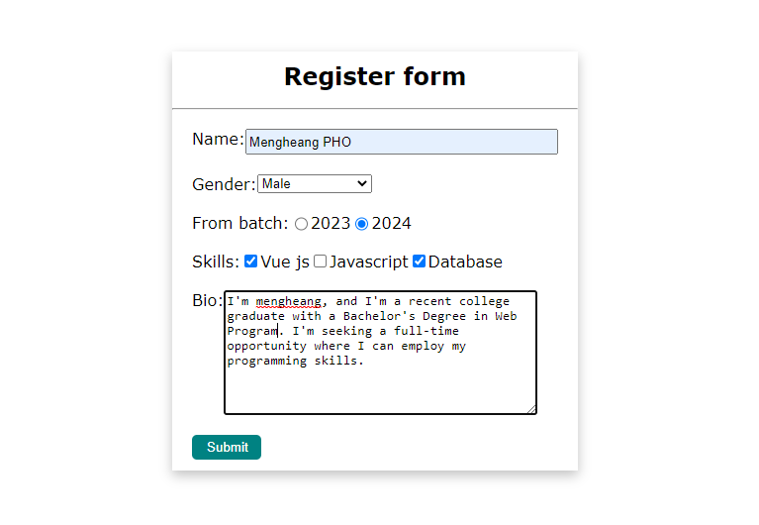

After you click submit it shold be hide the register form and show the user info block.

This is the User info block, so you need to collect all information from the register form into it. And show the information as below

This is the user info code:

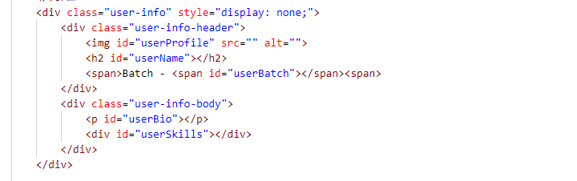

This is the user info template

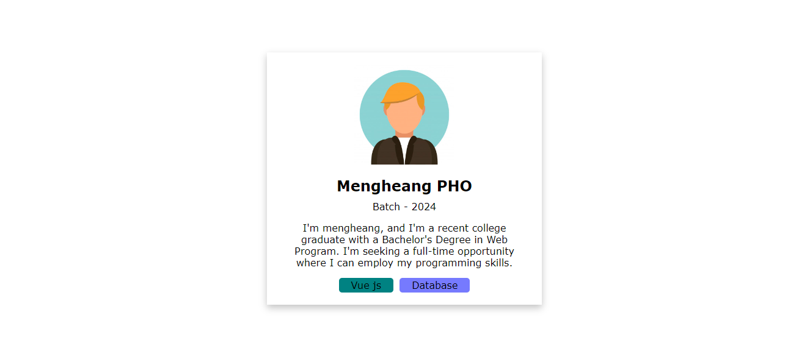

As you can see there is many skills that can be show be the Bio on the user info.

For each color that you see you can use it as a class of span. Each **first** character of each skill must be put as a class of span of skills. Example:

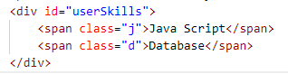

To be clear you can view the user-info expected file.

